EG334S
Cloud Computing Project

Simulating a Multi-Cloud Environment for HyEnt
Federating an On-Premises Data Centre with AWS and Azure using IPSec Site-to-Site VPN

Final Project Report

Project Team
Casper · Jeff · Bernard · Adeline · Soo Fern

Submitted: August 2026
Document status: DRAFT for team completion

Contents

(In Word: right-click the field above and choose "Update Field" to populate page numbers.)

Responsibility Assignment Table
This table records the work performed by each team member, as required by the project brief. Admin numbers to be completed by each member before submission.
Name | Admin No. | Role | Topic | Section | Remarks
Casper | [TBC] | Enterprise Cloud Architect | 1. Introduction, 2. Project Objectives, 8. Conclusion | 1.1–1.3, 2.1–2.2, 8.1–8.2 | Group leader / Chief Editor
Jeff | [TBC] | Enterprise Network Engineer | 5. AWS Infrastructure Design and Implementation | 5.1 VPC/VNet build, 5.3 VPN #1, 5.4 VPN #2 | Editor
Bernard | [TBC] | Technical Programme Manager / Security & Monitoring | 3. Schedule, Milestones and Deliverables; 5.7 Security, Monitoring and Cost Control | 3.1–3.3, 5.7 | Editor. Owns delivery, critical path, risk, security groups, CloudWatch / CloudTrail / Flow Logs, cost guardrails and teardown
Adeline | [TBC] | Web and Database Engineer | 4. Routing and IP Addressing; web server instances | 4.1 IP addressing scheme, 4.2 Routing | Editor
Soo Fern | [TBC] | Data Centre Operations Manager | 2. EC2 Instances, 6. Problems Encountered and Solutions | 6.1–6.9, Annex A | Researcher / Editor

1 Introduction
High Enterprise (HyEnt) is evaluating a new approach to managing its e-commerce web servers by federating its on-premises private cloud with a public cloud provider, and then extending that public cloud environment to a second provider to form a multi-cloud environment. This report documents the design, implementation, testing and decommissioning of a working simulation of that architecture.
The completed system comprises three independent, self-contained cloud cells joined by two IPSec site-to-site VPN tunnels over the public internet. All three cells were built, connected, tested end-to-end, and verified to carry both network-layer (ICMP) and application-layer (HTTP) traffic between cloud providers.

1.1 Scope of this report
This report covers the full project lifecycle: the addressing design that everything else depends on, the infrastructure build using Infrastructure-as-Code on both cloud platforms, the configuration of both VPN tunnels, the problems encountered and how each was resolved, the test results that demonstrate the system works, and the decommissioning procedure.

1.2 Summary of outcome
All four technical milestones were achieved. The addressing scheme was locked before any build work began; all three networks were deployed and verified; the first tunnel (on-premises to AWS public cloud) was brought up and passed traffic; and the second tunnel (AWS public cloud to Azure) was brought up, completing the multi-cloud environment. Both tunnels were confirmed operational simultaneously, with traffic verified in both directions.

2 Project Objectives
The objectives, derived from the project brief, were as follows.

2.1 Primary objectives
- Design and implement VPC and VNet networks for both the private and the public clouds, generated as Infrastructure-as-Code.
- Create a simple web-server instance in the subnet of the public cloud VPC/VNet.
- Create a simple server in the HyEnt private cloud for connection to the public cloud.
- Create and configure the virtual private gateway, VPN endpoint and VPN network interfaces on the public cloud subnet.
- Create and configure an IPSec customer gateway for the private cloud to connect over the internet to the AWS virtual private gateway.
- Create and configure an IPSec gateway for the Azure cloud to connect over the internet to the AWS public cloud.
- Test and verify that the multi-cloud environment is successfully implemented.
- Terminate and decommission all cloud resources after demonstration to the assessors.

2.2 Success criteria
The project was judged complete when traffic could be demonstrated flowing across both encrypted tunnels between distinct cloud cells, evidenced by tunnel telemetry from the cloud providers and by successful end-to-end tests from the workload servers themselves.

3 Schedule, Milestones and Deliverables
The schedule was deliberately back-planned from the immovable decommissioning deadline of Sunday 30 August 2026, 23:59 SGT, rather than forward from the project start. Marks are deducted for resources left running past that time, so it was treated as the fixed point around which all other work was arranged.

3.1 Critical path
The task order followed the real dependency chain rather than the order in which the brief lists the tasks:
CIDR scheme → networks → compute → VPN #1 → VPN #2 → end-to-end test → demonstration → decommission
The addressing scheme was front-loaded because every subsequent decision inherits from it. Anything not on this chain (bonus features, report polish, slide design) was treated as parallel work to be sacrificed first if time ran short.

3.2 Milestones
Milestone | Definition | Status
M1 CIDR scheme locked | One agreed, non-overlapping addressing table for all three cells | Achieved
M2 All three networks live | Two AWS VPCs and the Azure VNet deployed; compute reachable within each cell | Achieved
M3 First tunnel passing traffic | On-premises to AWS public cloud over IPSec, verified with real traffic | Achieved
M4 Multi-cloud proven | Second tunnel up; traffic verified across cloud providers | Achieved
M5 Assessed demonstration | System demonstrated live to assessors before any teardown | Scheduled
M6 Fully decommissioned | Nothing left running in any region or subscription | By 30 Aug 2026, 23:59 SGT

3.3 Deliverables
- Working multi-cloud system across three cells and two IPSec tunnels (demonstrated live).
- Infrastructure-as-Code: CloudFormation templates (AWS) and a Bicep template (Azure).
- This report, including configuration, test evidence and screenshots.
- Individual presentations.
- Full decommissioning of all resources, verified per region and per subscription.

4 Project Team and Organization
The team was organised into five roles, each owning a technical slice of the system and a corresponding section of this report. The Responsibility Assignment Table at the front of this report records the detailed allocation.

4.1 Roles
Member | Role | Ownership
Casper | Enterprise Cloud Architect | Overall architecture, CIDR sign-off, executive summary and conclusion
Jeff | Enterprise Network Engineer | VPC and VNet build, both IPSec tunnels, gateway configuration
Bernard | Technical Programme Manager, Security and Monitoring | Delivery and critical path, risk register, cost guardrails, teardown coordination, CloudWatch/CloudTrail/Flow Logs
Adeline | Web and Database Engineer | IP addressing scheme, routing, public-subnet web server
Soo Fern | Data Centre Operations Manager | EC2 instances, DNS/DHCP, problems and solutions log

4.2 Working method
Because 60% of the assessment is individual (Checkpoint and Presentation) and 40% is group (System Demo and Report), the team built the system collaboratively but each member retained sole ownership of one technical slice, so that every member could independently explain and defend their own contribution.

5 AWS Infrastructure Design and Implementation

5.1 Architecture overview
The system consists of three self-contained cloud cells. The AWS public cloud cell acts as the hub: its single Virtual Private Gateway terminates both IPSec tunnels. Figure 5.0 shows the architecture as built, including the gateway resources at each end of each tunnel and the two platform constraints that shaped the design.

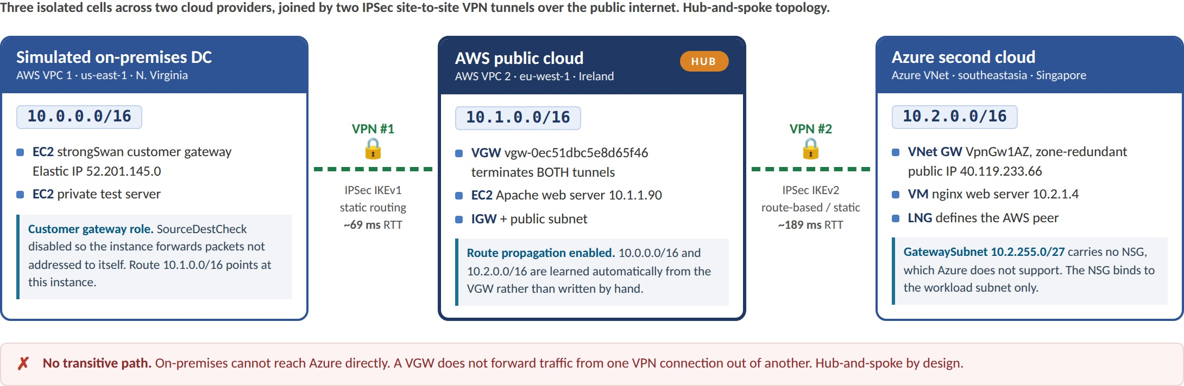
Figure 5.0. Logical architecture as built: three cells, two providers, two IPSec site-to-site tunnels, hub-and-spoke
Reading the diagram: each cell is an isolated private network with a non-overlapping CIDR. The two links are genuine IPSec security associations over the public internet rather than VPC peering, so traffic is encrypted and routed rather than simply bridged. The AWS public cloud cell is the hub because its single Virtual Private Gateway terminates both connections. The round-trip times shown are measured from the ICMP tests in section 7, and every reply returned ttl=254, decremented from 255, which confirms the packets crossed a gateway rather than being answered locally.

Cell | Cloud and region | CIDR | Compute
Simulated on-premises data centre | AWS us-east-1 (N. Virginia) | 10.0.0.0/16 | strongSwan customer gateway, test server
AWS public cloud (hub) | AWS eu-west-1 (Ireland) | 10.1.0.0/16 | Apache web server (10.1.1.90)
Azure second public cloud | Azure southeastasia (Singapore) | 10.2.0.0/16 | nginx web server (10.2.1.4)

5.1.1 Region selection and rationale
The two AWS VPCs were deliberately placed in different regions (N. Virginia and Ireland) so that the on-premises to public-cloud tunnel is genuinely cross-region and traverses the public internet, as the scenario requires.
The Azure cell was placed in Singapore rather than alongside the AWS public cell in Ireland. This was a considered trade-off. Placing Azure in Ireland would have minimised the VPN #2 tunnel latency to roughly 15 ms, but every interactive action during the assessed demonstration would then cross to Europe. Placing Azure in Singapore instead gives near-zero latency for the demonstration and for management, at the cost of a longer tunnel (approximately 189 ms). Since tunnel latency is invisible to an observer and demonstration responsiveness is not, Singapore was chosen. It also better reflects the business scenario, in which HyEnt is a Singapore enterprise placing its second cloud provider close to its user base.

5.2 IP addressing scheme
Non-overlapping address ranges were agreed and locked before any infrastructure was built. Overlapping ranges are the single most common cause of a VPN tunnel establishing correctly while carrying no traffic, because the routing becomes ambiguous.
Cell | VPC / VNet CIDR | Workload subnet | Gateway subnet
On-premises (us-east-1) | 10.0.0.0/16 | 10.0.1.0/24 | n/a (software gateway)
AWS public (eu-west-1) | 10.1.0.0/16 | 10.1.1.0/24 | n/a (managed VGW)
Azure (southeastasia) | 10.2.0.0/16 | 10.2.1.0/24 | GatewaySubnet 10.2.255.0/27

5.3 Infrastructure as Code
All infrastructure was defined as code rather than created by hand in the consoles. On AWS this was CloudFormation in YAML, generated with the assistance of Amazon Q as required by the brief. On Azure this was a Bicep template, which is the equivalent declarative format for that platform.
This choice had two practical benefits beyond reproducibility. First, it made cost control straightforward: the environment could be deleted between working sessions and rebuilt in minutes, rather than being left running. Second, it made the final decommissioning safe and complete, because deleting a stack removes resources in the correct dependency order rather than relying on manual clean-up.

5.3.1 Extract: on-premises cell (CloudFormation, us-east-1)
Resources:
Vpc1:
Type: AWS::EC2::VPC
Properties:
CidrBlock: 10.0.0.0/16
EnableDnsSupport: true
EnableDnsHostnames: true

# Route traffic destined for the AWS public cell via the strongSwan box
RouteToAwsPublic:
Type: AWS::EC2::Route
Properties:
RouteTableId: !Ref RouteTable
DestinationCidrBlock: 10.1.0.0/16
InstanceId: !Ref StrongSwanInstance

StrongSwanInstance:
Type: AWS::EC2::Instance
Properties:
ImageId: '{{resolve:ssm:/aws/service/ami-amazon-linux-latest/amzn2-ami-hvm-x86_64-gp2}}'
# CRITICAL: a router must forward packets not addressed to itself
SourceDestCheck: false
Figure 5.1. Extract from the on-premises cell CloudFormation template

5.3.2 Extract: AWS public cell and VPN #1 (CloudFormation, eu-west-1)
Vgw:
Type: AWS::EC2::VPNGateway
Properties: { Type: ipsec.1 }

RoutePropagation:
Type: AWS::EC2::VPNGatewayRoutePropagation
Properties:
RouteTableIds: [ !Ref RouteTable ]
VpnGatewayId: !Ref Vgw

CustomerGateway:
Type: AWS::EC2::CustomerGateway
Properties:
Type: ipsec.1
BgpAsn: 65000
IpAddress: !Ref OnPremStrongSwanEIP # 52.201.145.0

VpnConnection:
Type: AWS::EC2::VPNConnection
Properties:
Type: ipsec.1
StaticRoutesOnly: true
CustomerGatewayId: !Ref CustomerGateway
VpnGatewayId: !Ref Vgw
Figure 5.2. Virtual private gateway, customer gateway and VPN connection

5.3.3 Extract: Azure cell (Bicep, southeastasia)
var vnetCidr = '10.2.0.0/16'
// Name must be exactly GatewaySubnet - Azure places the VPN gateway by this name.
// /27 minimum for all SKUs except Basic.
var gatewaySubnetCidr = '10.2.255.0/27'

resource vnet 'Microsoft.Network/virtualNetworks@2023-11-01' = {
name: vnetName
properties: {
addressSpace: { addressPrefixes: [ vnetCidr ] }
subnets: [
{
name: workloadSubnetName
properties: {
addressPrefix: '10.2.1.0/24'
networkSecurityGroup: { id: nsg.id }
}
}
{
name: 'GatewaySubnet'
properties: { addressPrefix: gatewaySubnetCidr }
// Deliberately NO networkSecurityGroup - unsupported by Azure
}
]
}
}
Figure 5.3. Azure VNet with workload subnet and GatewaySubnet

5.4 VPN #1, on-premises to AWS public cloud
AWS Site-to-Site VPN is a managed service that provides only one end of the tunnel: the Virtual Private Gateway. The other end must be a real device with a public IP address running IPSec, which AWS calls the Customer Gateway. Because the simulated on-premises data centre is itself an AWS VPC, no such device exists natively, so one was built: an EC2 instance running strongSwan, with an Elastic IP.
Understanding this asymmetry is the key to the whole exercise. AWS builds one end; the other end must be supplied.

5.4.1 strongSwan configuration
conn %default
keyexchange=ikev1
authby=secret
ike=aes128-sha1-modp1024
esp=aes128-sha1-modp1024
dpdaction=restart
left=%defaultroute
leftid=52.201.145.0 # the Elastic IP, NOT the private IP
leftsubnet=10.0.0.0/16
rightsubnet=10.1.0.0/16

conn aws-t1
right=34.247.143.4
auto=start
Figure 5.4. strongSwan ipsec.conf on the simulated on-premises customer gateway
The leftid parameter must be the public Elastic IP rather than the instance private IP. The instance sits behind AWS NAT, so during IKE negotiation it must present its public identity. Setting this incorrectly causes the tunnel to fail silently.

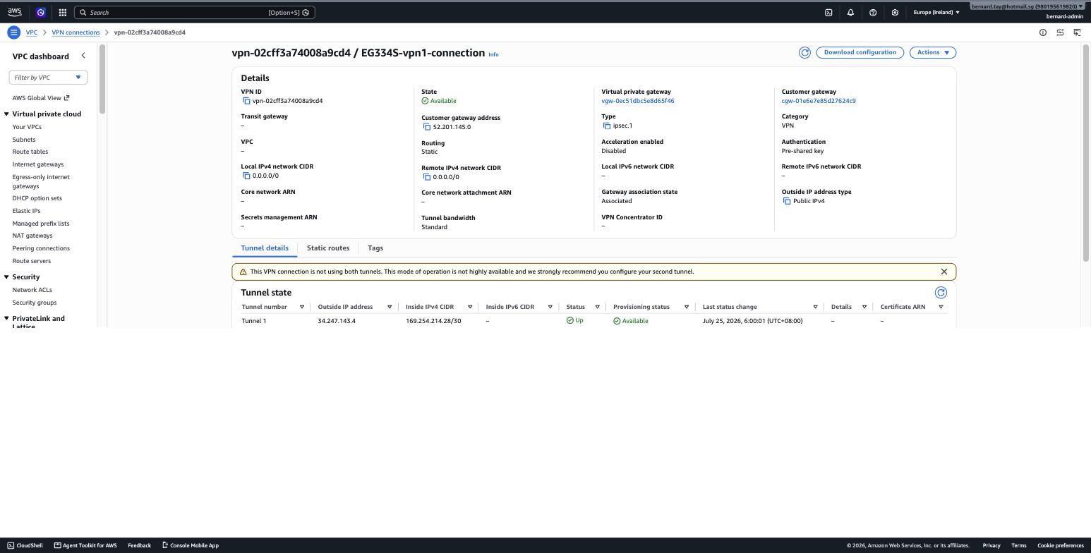
Figure 5.5. VPN #1 in the AWS console: customer gateway 52.201.145.0, tunnel 34.247.143.4 status Up

5.5 VPN #2, AWS public cloud to Azure
The second tunnel connects the AWS public cloud cell to the Azure cell. The same conceptual components exist on both platforms under different names.
Role | AWS term | Azure term | Resource in this build
Local gateway | Virtual Private Gateway | Virtual Network Gateway | vgw-0ec51dbc5e8d65f46 / eg334s-vpngw
Remote peer definition | Customer Gateway | Local Network Gateway | cgw-072f6b49c61f06f30 / eg334s-aws-lng
The tunnel itself | VPN Connection | Connection | vpn-0f2dd8409e8290710 / eg334s-vpn2-connection

The Azure gateway was created as a VpnGw1AZ, Generation1, route-based gateway with a zone-redundant Standard static public IP. It was allocated the address 40.119.233.66, which became the Customer Gateway address on the AWS side.
A practical sequencing point: the Azure Virtual Network Gateway takes approximately 30 to 45 minutes to provision, whereas the AWS gateway takes minutes. The public IP is assigned immediately on creation, so the correct order is to create the Azure public IP first, start the gateway provisioning in the background, and build the entire AWS side while it completes. Performing these steps serially wastes half an hour.

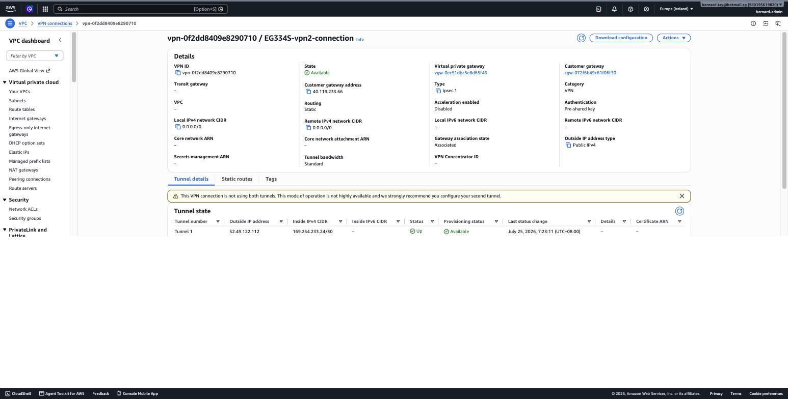
Figure 5.6. VPN #2 in the AWS console: customer gateway 40.119.233.66 (Azure), tunnel 52.49.122.112 status Up

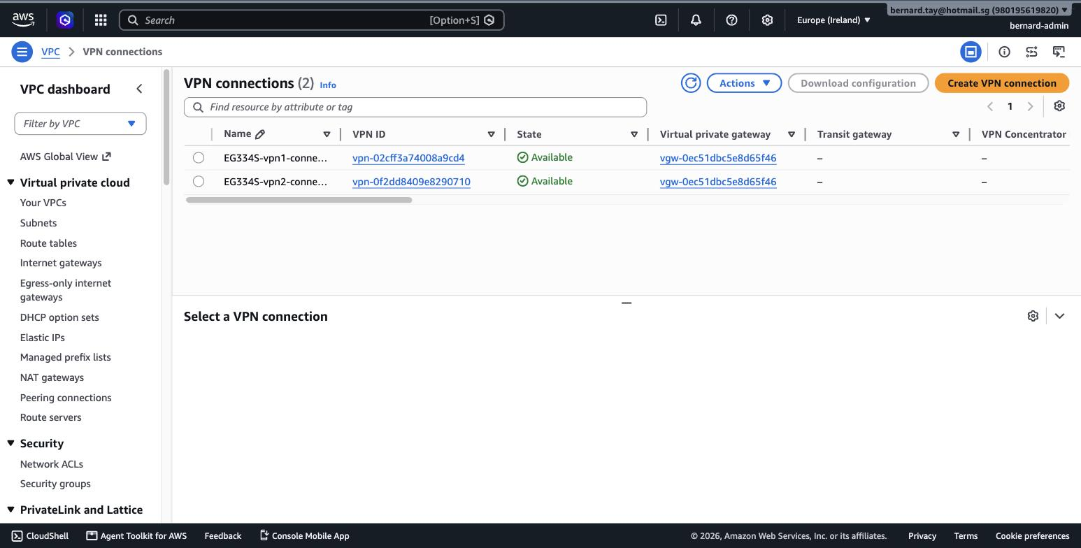
Figure 5.7. Both VPN connections Available on the same Virtual Private Gateway, confirming the hub topology

5.6 Routing
Route propagation was enabled on the AWS public cloud route table, so both remote networks are learned automatically from the Virtual Private Gateway rather than being entered by hand.
Destination Target Status Propagated Origin
10.1.0.0/16 local Active No Create Route Table
0.0.0.0/0 igw-09bb75a24affcb9a1 Active No Create Route
10.0.0.0/16 vgw-0ec51dbc5e8d65f46 Active Yes Virtual Private Gateway
10.2.0.0/16 vgw-0ec51dbc5e8d65f46 Active Yes Virtual Private Gateway
Figure 5.8. AWS public cloud route table showing both remote networks propagated

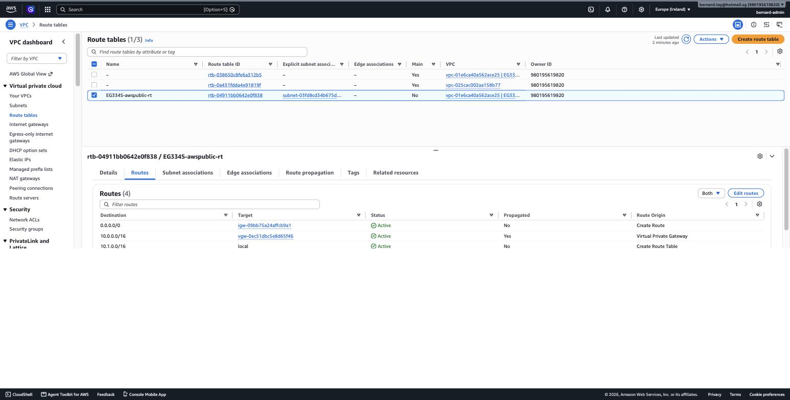
Figure 5.9. The same route table in the AWS console, four routes, both remote networks learned via the VGW

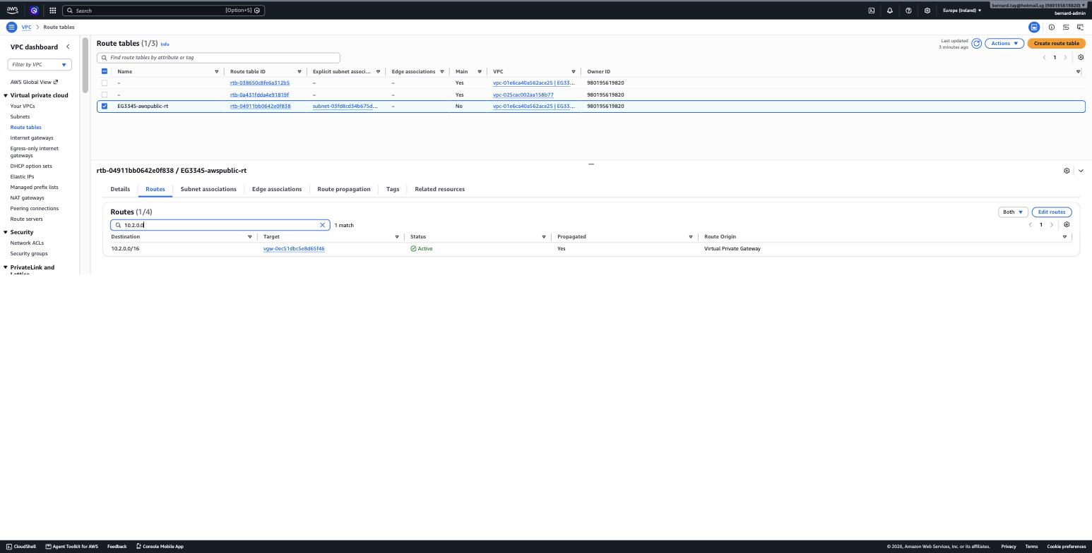
Figure 5.10. The Azure network 10.2.0.0/16 propagated to the VGW, Active

5.7 Security, monitoring and cost control
Security groups and network security groups were scoped to the specific remote networks rather than left open. The AWS web server permits ICMP and HTTP only from 10.0.0.0/16 and 10.2.0.0/16; the Azure network security group permits ICMP from the two AWS ranges. Note that Azure does not support attaching a network security group to the GatewaySubnet, so the NSG is bound to the workload subnet only. One weakness is recorded deliberately rather than concealed: SSH remains open to 0.0.0.0/0 on the laboratory hosts. In a production build that rule would be narrowed to a single administrative /32.
Preventive controls alone are not sufficient, because they cannot tell the operator when something has broken or when something unexpected has been done to the environment. Three detective controls were therefore added. First, an Amazon CloudWatch alarm was created for each VPN connection on the AWS/VPN TunnelState metric, alarming when the value falls below 1 and configured with treat-missing-data set to breaching so that an absence of data is itself treated as a fault. Both alarms publish to an Amazon SNS topic with a confirmed email subscription. Second, an AWS CloudTrail trail was enabled as a multi-region trail with log file validation switched on, so that every management API call against the account is recorded and the resulting log files are tamper-evident. Third, VPC Flow Logs were enabled on both AWS VPCs, delivering to a dedicated Amazon S3 bucket, which gives packet-level visibility of what actually traverses the tunnels rather than only whether the tunnels are up. A CloudWatch dashboard consolidates tunnel state, tunnel traffic and instance CPU on a single view for the demonstration.
The distinction between the two categories is the point. A security group decides what is allowed; an alarm, a trail and a flow log decide what is noticed. At the time of writing both alarms report OK against live telemetry, the trail reports IsLogging true, and both flow logs report ACTIVE with objects already delivered to the bucket, which confirms the controls are operating rather than merely configured.
Because the project has a hard decommissioning deadline with a mark penalty, cost guardrails were treated as a delivery control rather than a financial one. Two AWS Budgets were created: a monthly budget of $40 with alerts at 50%, 80% and 100% of actual plus 100% of forecast, and a daily tripwire of $3. The daily tripwire is the one that matters, because it detects resources accidentally left running within a day rather than at month end. Cost Anomaly Detection was also enabled, and a scheduled daily check reports any running instances, VPN connections or Elastic IPs across both regions.
Evidence of the monitoring configuration, taken from the live account:
$ aws cloudwatch describe-alarms --region eu-west-1 --alarm-name-prefix EG334S
EG334S-VPN1-TunnelDown TunnelState State: OK
EG334S-VPN2-TunnelDown TunnelState State: OK

$ aws cloudtrail get-trail-status --region eu-west-1 --name EG334S-audit-trail
{ "IsLogging": true }

$ aws ec2 describe-flow-logs --region eu-west-1
fl-08c0fdca54d7dd957 vpc-01e6ca40a562ace25 ACTIVE -> s3://eg334s-flowlogs-980195619820
$ aws ec2 describe-flow-logs --region us-east-1
fl-09ed4fed7a0b7fa2c vpc-09dc34d62dea2189b ACTIVE

6 Problems Encountered and Solutions
This section records the significant problems met during implementation and how each was resolved. Several are genuine platform differences between AWS and Azure rather than mistakes, and are recorded because they are the kind of issue that would recur on any similar project.

6.1 AWS Site-to-Site VPN provides only one end of the tunnel
Symptom: there is no AWS feature that simply joins two VPCs with an IPSec tunnel.
Cause: AWS Site-to-Site VPN is designed to connect a VPC to external equipment. It supplies the Virtual Private Gateway and expects the customer to supply a real IPSec device at the other end.
Solution: an EC2 instance running strongSwan was deployed in the simulated on-premises VPC and given an Elastic IP, and that address was registered as the Customer Gateway. VPC Peering was explicitly rejected as an alternative because it is not IPSec and does not traverse the public internet, so it would not satisfy the brief.

6.2 Tunnel establishes but no traffic passes
Symptom: tunnel telemetry reports UP, but pings between cells fail.
Cause: this is almost always a routing or security-group gap rather than a VPN fault. In this build the specific cause was that an EC2 instance acting as a router drops packets not addressed to itself unless source/destination checking is disabled.
Solution: SourceDestCheck was set to false on the strongSwan instance, the on-premises route table was given a route for 10.1.0.0/16 via that instance, and route propagation was enabled on the AWS side. The general lesson is that "tunnel UP" means only that the two gateways completed a handshake; it says nothing about whether packets can traverse.

6.3 Restricted IAM permissions on the build account
Symptom: stack creation failed with an explicit deny on iam:CreateRole, and a subsequent rollback became stuck in ROLLBACK_FAILED because ec2:DeleteVpc was also denied.
Cause: the account carries a guardrail policy that denies destructive and IAM actions when the caller is an automated agent.
Solution: the design was changed to avoid IAM entirely, using an SSH key pair rather than an SSM instance role. More importantly, all subsequent stacks were created with --on-failure DO_NOTHING. By default CloudFormation rolls back on failure, and rollback deletes resources; where deletion is denied, this leaves the stack wedged. DO_NOTHING leaves a clean CREATE_FAILED stack that can be deleted normally. The VPN #2 AWS resources were also placed in a separate stack so that any rollback would be confined to resources whose deletion is permitted.

6.4 Azure resource providers not registered
Symptom: MissingSubscriptionRegistration, the subscription is not registered to use namespace Microsoft.Network.
Cause: Azure gates each service namespace per subscription. A new subscription cannot create virtual networks, network interfaces or public IPs until the provider is explicitly registered. AWS has no equivalent step; services are simply available.
Solution: az provider register --namespace Microsoft.Network --wait, and the same for Microsoft.Compute. Registration is subscription-wide and persists.

6.5 Azure VM size unavailable, then quota exhausted
Symptom: first SkuNotAvailable for Standard_B1s, then QuotaExceeded for the ARM B-series family with a stated limit of zero cores.
Cause: availability and quota are two separate gates in Azure and both must pass. A size can be offered in a region while the subscription holds no allowance for its family.
Solution: rather than continuing to guess at sizes, the subscription quota was read directly with az vm list-usage. This showed Standard Dalsv7 Family with a limit of 10 cores and a Total Regional vCPUs limit of 10. Standard_D2als_v7 satisfied both gates and deployed successfully first time. The lesson is to read quota before choosing a size, not after.

6.6 CPU architecture encoded in the Azure VM size name
Symptom: the available B-series sizes in Singapore all contained a "p" (for example B2pls_v2), which denotes ARM64 rather than x86.
Cause: Azure encodes processor architecture in the size name, and an ARM size will not boot an x86 image.
Solution: the Ubuntu image SKU must match the architecture. Use 22_04-lts-arm64 for ARM sizes and 22_04-lts-gen2 for x86. When the final size choice reverted to the AMD x86 D2als_v7, the image was reverted accordingly.

6.7 Azure has retired the non-AZ VPN gateway SKUs
Symptom: NonAzSkusNotAllowedForVPNGateway when attempting to create a VpnGw1 gateway.
Cause: VpnGw1 through VpnGw5 can no longer be created; only the availability-zone variants remain.
Solution: VpnGw1AZ was used instead. An AZ-SKU gateway additionally requires a zone-redundant public IP, so the Standard public IP had to be deleted and recreated with --zone 1 2 3. Note also that Basic SKU public IPs are retired, so Standard with static allocation is now the only valid choice.

6.8 The ordering dependency between the two clouds
Symptom: neither side of a tunnel can be fully configured before the other.
Cause: the AWS Customer Gateway needs the remote public IP, but the remote side needs the tunnel address and pre-shared key that AWS only generates after the VPN connection exists.
Solution: the dependency was walked in a fixed order rather than automated away. The order is the remote public IP first, then the AWS customer gateway, then AWS VPN connection, then the remote local network gateway and connection using the generated key. This seam is inherently manual and was documented as such in the runbooks. Figure 6.1 sets out the full chain and marks which side of the build performs each step.

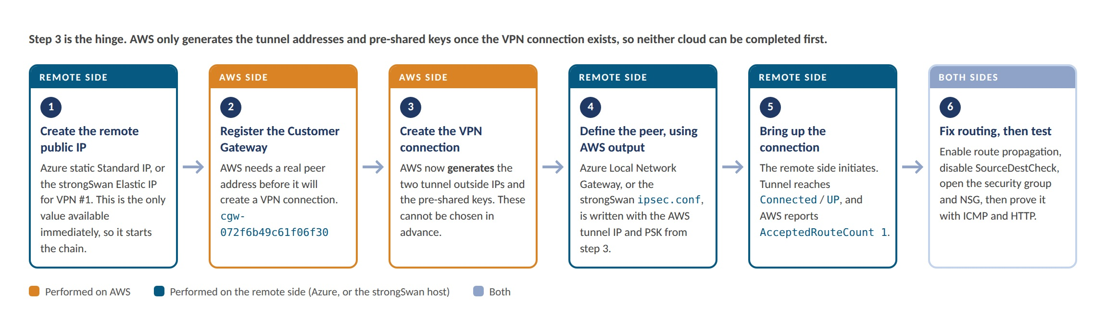
Figure 6.1. The cross-cloud build order, and which side of the build performs each step
Step 3 is the hinge. AWS will not create a VPN connection without a Customer Gateway, a Customer Gateway requires a real remote public IP, and the tunnel addresses and pre-shared keys do not exist until the VPN connection itself has been created. The remote side therefore cannot be completed first, and neither can the AWS side. The seam has to be walked once, in this order, by hand. This is also why the Azure Virtual Network Gateway was started with --no-wait, so that its roughly thirty minutes of provisioning ran in parallel with the entire AWS build rather than after it.
Steps 5 and 6 are deliberately separate. A tunnel reporting UP means only that two gateways completed an IKE handshake; it says nothing about whether a packet can traverse. Every failure in this project that first appeared to be a VPN fault turned out to be a step 6 problem: a missing route, an instance dropping packets not addressed to itself, or a closed security group.

6.9 No transitive routing between the two tunnels
Symptom: the on-premises server cannot reach the Azure network, despite both tunnels being operational.
Cause: an AWS Virtual Private Gateway does not perform transitive routing between two VPN connections. Traffic arriving on one tunnel is not re-forwarded out of the other.
Assessment: this is correct behaviour, not a defect. The topology is hub-and-spoke with the AWS public cloud as the hub, which is exactly the architecture described in the project brief. Enabling a full mesh would require replacing the Virtual Private Gateway with an AWS Transit Gateway, which supports transitive routing between attachments at additional hourly and per-attachment cost. This was judged unnecessary for the stated scenario. The behaviour was deliberately tested and is recorded in Section 7 as a negative test.

7 Test Results
Testing was carried out at two levels for each tunnel: the control plane (do the two gateways agree that a tunnel exists?) and the data plane (do packets actually traverse it?). Both are necessary, because a tunnel can report UP while carrying no traffic.

7.1 Test summary
# | Test | Expected | Result
1 | VPN #1 data plane: on-premises to AWS public | Reply, 0% loss | PASS. 0% loss, ttl 254, ~69 ms
2 | VPN #1 IPSec security association established | ESTABLISHED, correct selectors | PASS
3 | VPN #2 data plane: Azure to AWS public | Reply, 0% loss | PASS. 0% loss, ttl 254, ~189 ms
4 | VPN #2 application layer: HTTP across clouds | AWS web page returned | PASS
5 | Azure web server reachable | Azure web page returned | PASS
6 | Transitive routing: on-premises to Azure | Fail (by design) | EXPECTED FAIL. 100% loss

7.2 Test 1, VPN #1 data plane
[ec2-user@on-prem ~]$ ping -c 2 10.1.1.90
PING 10.1.1.90 (10.1.1.90) 56(84) bytes of data.
64 bytes from 10.1.1.90: icmp_seq=1 ttl=254 time=69.4 ms
64 bytes from 10.1.1.90: icmp_seq=2 ttl=254 time=69.3 ms

--- 10.1.1.90 ping statistics ---
2 packets transmitted, 2 received, 0% packet loss, time 1001ms
Figure 7.1. ICMP from the simulated on-premises cell to the AWS public cloud web server

7.3 Test 2, VPN #1 IPSec security association
Security Associations (1 up, 0 connecting):
aws-t1[1]: ESTABLISHED, 10.0.1.193[52.201.145.0]...34.247.143.4[34.247.143.4]
aws-t1{1}: INSTALLED, TUNNEL, reqid 1, ESP in UDP SPIs: c645a39a_i cd37ae8a_o
aws-t1{1}: 10.0.0.0/16 === 10.1.0.0/16
Figure 7.2. strongswan statusall output
Two details confirm correct operation. "ESP in UDP" shows that NAT traversal is in use, which is expected because the strongSwan instance sits behind AWS NAT and presents its Elastic IP as its identity. The traffic selector 10.0.0.0/16 === 10.1.0.0/16 confirms both networks are correctly bound to the tunnel.

7.4 Test 3, VPN #2 data plane (cross-cloud)
azureuser@eg334s-azure-server:~$ ping -c 4 10.1.1.90
PING 10.1.1.90 (10.1.1.90) 56(84) bytes of data.
64 bytes from 10.1.1.90: icmp_seq=1 ttl=254 time=187 ms
64 bytes from 10.1.1.90: icmp_seq=2 ttl=254 time=189 ms
64 bytes from 10.1.1.90: icmp_seq=3 ttl=254 time=191 ms
64 bytes from 10.1.1.90: icmp_seq=4 ttl=254 time=190 ms

--- 10.1.1.90 ping statistics ---
4 packets transmitted, 4 received, 0% packet loss, time 3005ms
rtt min/avg/max/mdev = 187.452/189.368/190.743/1.339 ms
Figure 7.3. ICMP from the Azure cell to the AWS public cloud web server, across two cloud providers

7.5 Test 4, Application-layer traffic across the cross-cloud tunnel
azureuser@eg334s-azure-server:~$ curl http://10.1.1.90
<h1>EG334S AWS Public Cloud Web Server (eu-west-1)</h1>
Figure 7.4. HTTP request from Azure returning the AWS web server page
This is the strongest single result in the project. It is not merely a ping: a complete application-layer request was issued from a virtual machine in Microsoft Azure in Singapore, traversed an encrypted IPSec tunnel over the public internet, was served by an Apache instance in Amazon Web Services in Ireland, and the response returned by the same path.

7.6 Test 6, Transitive routing (negative test)
[ec2-user@on-prem ~]$ ping -c 2 -W 3 10.2.1.4
PING 10.2.1.4 (10.2.1.4) 56(84) bytes of data.

--- 10.2.1.4 ping statistics ---
2 packets transmitted, 0 received, 100% packet loss, time 1025ms
Figure 7.5. On-premises to Azure: no route, as expected
This test was run deliberately to establish and document the boundary of the architecture. The result is correct behaviour and is explained in Section 6.9.

7.7 Latency analysis
Both tunnels are genuine IPSec connections over the public internet. The difference in round-trip time is a function of physical distance alone.
Tunnel | Path | Round-trip time
VPN #1 | N. Virginia to Ireland (trans-Atlantic) | approximately 69 ms
VPN #2 | Ireland to Singapore (half-way round the world) | approximately 189 ms

A time-to-live of 254 on every reply, decremented from the initial 255, confirms that each packet passed through a gateway rather than being answered locally. This is a useful check that the traffic genuinely traversed the tunnel.

8 Conclusion
The project successfully delivered a working simulation of a multi-cloud environment for HyEnt. Three self-contained cloud cells were built across two cloud providers and three geographic regions, joined by two IPSec site-to-site VPN tunnels over the public internet, and both network-layer and application-layer traffic were verified flowing between providers.

8.1 What the team learned
The most valuable technical insight was that AWS Site-to-Site VPN supplies only one end of a tunnel. Recognising that the other end must be built, and building it with strongSwan, was the step that made the rest of the project tractable.
The most valuable operational insight was that a tunnel reporting UP proves very little. Four times out of five, a VPN that will not carry traffic has a routing or security-group problem rather than an IPSec problem, and the parts the team built themselves should be suspected before the parts the cloud provider manages.
Working across two providers also made their differences concrete in a way that reading documentation does not. Azure gates service namespaces and compute quota per subscription where AWS does not; Azure encodes CPU architecture in VM size names; Azure requires a specifically named GatewaySubnet that must not carry a network security group; and Azure VPN gateways take roughly thirty times longer to provision than their AWS equivalent. Each of these cost time on first encounter and none of them is obvious in advance.

8.2 Design decisions and their trade-offs
Two decisions are worth restating because they were deliberate trade-offs rather than defaults. Placing the Azure cell in Singapore rather than beside the AWS cell in Ireland accepted a longer tunnel in exchange for a responsive demonstration and a more coherent business narrative. Retaining the Virtual Private Gateway rather than adopting a Transit Gateway accepted the absence of transitive routing, which the scenario does not require, in exchange for lower cost and complexity.

8.3 Decommissioning
Because the entire environment is defined as code on both platforms, decommissioning is deterministic rather than a manual search for stray resources. Resources exist per region and per subscription, so teardown must be performed in three places: AWS us-east-1, AWS eu-west-1, and the Azure resource group. On AWS the VPN #2 stack must be deleted before the AWS public cloud stack, because it references that stack's Virtual Private Gateway.
# Azure - one resource group holds the entire cell
az group delete --name eg334s-rg --yes

# AWS eu-west-1 - VPN #2 stack first (it borrows the VGW)
aws cloudformation delete-stack --region eu-west-1 --stack-name eg334s-vpn2-aws
aws cloudformation delete-stack --region eu-west-1 --stack-name eg334s-vpn1-awspublic

# AWS us-east-1
aws cloudformation delete-stack --region us-east-1 --stack-name eg334s-vpn1-onprem
Figure 8.1. Decommissioning commands
Completion is verified by confirming that no VPN connections, running instances or allocated Elastic IPs remain in either AWS region, and that az resource list --tag Project=EG334S returns no results.

Annex A. Bibliography
Amazon Web Services (2026) Amazon Virtual Private Cloud User Guide. Available at: https://docs.aws.amazon.com/vpc/latest/userguide/ (Accessed: July 2026).
Amazon Web Services (2026) AWS Site-to-Site VPN User Guide. Available at: https://docs.aws.amazon.com/vpn/latest/s2svpn/ (Accessed: July 2026).
Amazon Web Services (2026) AWS CloudFormation User Guide. Available at: https://docs.aws.amazon.com/AWSCloudFormation/latest/UserGuide/ (Accessed: July 2026).
Amazon Web Services (2026) Manage security groups with CloudFormation. Available at: https://docs.aws.amazon.com/AWSCloudFormation/latest/UserGuide/ (Accessed: July 2026).
Microsoft (2026) About VPN Gateway configuration settings. Available at: https://learn.microsoft.com/azure/vpn-gateway/vpn-gateway-about-vpn-gateway-settings (Accessed: July 2026).
Microsoft (2026) Tutorial: Create a site-to-site VPN connection in the Azure portal. Available at: https://learn.microsoft.com/azure/vpn-gateway/tutorial-site-to-site-portal (Accessed: July 2026).
Microsoft (2026) Create a route-based VPN gateway using CLI. Available at: https://learn.microsoft.com/azure/vpn-gateway/create-routebased-vpn-gateway-cli (Accessed: July 2026).
Microsoft (2026) VPN Gateway FAQ. Available at: https://learn.microsoft.com/azure/vpn-gateway/vpn-gateway-vpn-faq (Accessed: July 2026).
Microsoft (2026) Bicep documentation. Available at: https://learn.microsoft.com/azure/azure-resource-manager/bicep/ (Accessed: July 2026).
strongSwan Project (2026) strongSwan Documentation: ipsec.conf reference. Available at: https://docs.strongswan.org/ (Accessed: July 2026).

Note to the team: add any further sources consulted, and confirm the citation style required by the module before submission.

